The lecture 2
Microsoft Office 365 is a Microsoft subscription‐based software service that enables users to access their documents and collaborate with others from anywhere using their computers, the Internet, or their smart devices. Office 365 moves the traditional Office suite to the cloud. The service includes Office 365 apps (Word, Excel, PowerPoint, Outlook, OneNote, Access, and Publisher), Exchange Online, SharePoint Online, and Skype for Business Online. By using Office 365, you can offload many of the administrative tasks normally handled by your IT department. These tasks include managing software updates, patches, and service packs as well as purchasing additional server hardware to support company growth. Administration is handled through a web portal/dashboard in which you can create/manage user accounts and oversee the health of all services. Microsoft also provides tools to migrate from your existing on‐premise Exchange Server to Office 365. The service can be used in combination with the desktop version of Office and also works even if you don't have Office installed on your computers. Office 365 is available in a number of different plans designed to meet different segments of the market. Each plan uses a per‐user/month charge and provides access to either the entire service or only subsets of Office 365.

The following are features available with Microsoft Office 365:
- Users can access email, calendars, and contacts using the Microsoft Exchange service.
The applications can be delivered to Outlook or Outlook Web Access.
- Users can create, edit, and store documents they create with Office Web Apps, which are browser‐based versions of the standard Office suite (Word Online, PowerPoint Online, and Excel Online), as shown in Figure 2-1. These documents are fully compatible with the desktop versions of Office.
- Users can set up and maintain a company website.
- Users can connect immediately with their co‐workers via instant messaging by using Skype for Business.
- Users can set up and conduct online meetings (audio, video, and web conferencing), including the ability to share desktops, files, and presentations online.
- Users can share documents inside and outside of the organization and collaborate with their colleagues by using Microsoft SharePoint.

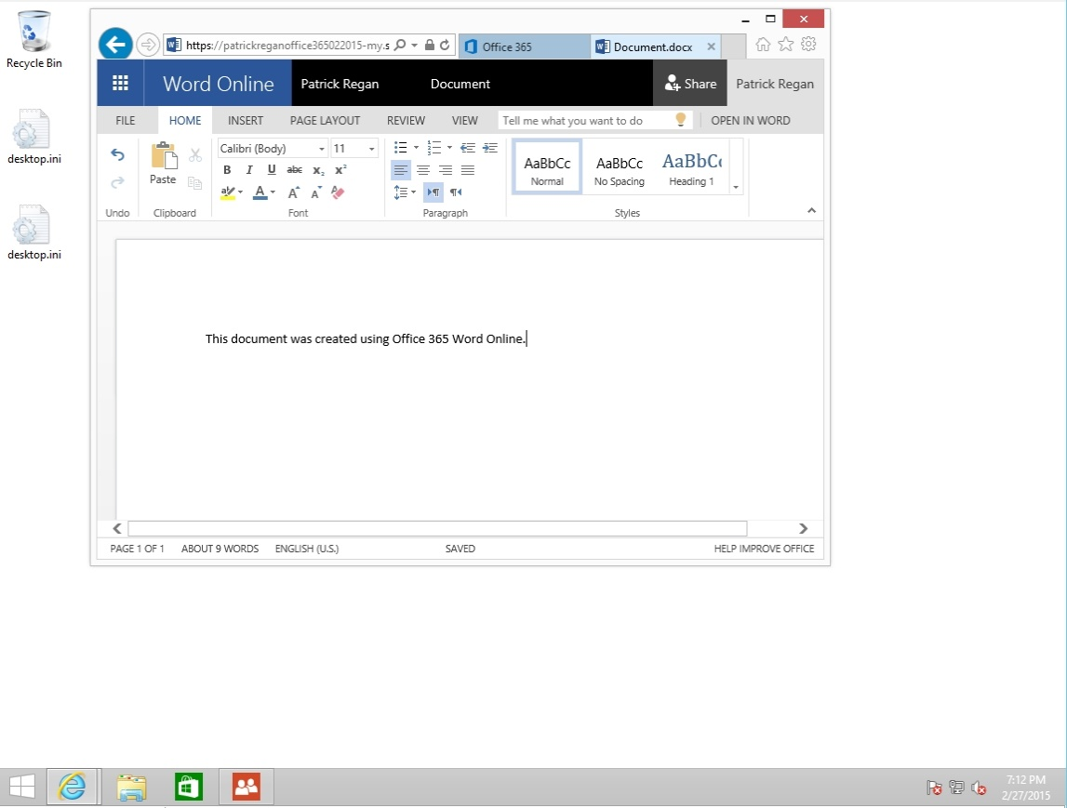
Figure 2-1. Using Word Online

From an administrative perspective, Office 365 offers several benefits:
- Maintenance: Microsoft performs the administrative tasks, so you do not have to manage backups, patches, and software updates for Office Online. However, if you install Office on the local computer, you will still have to manage backups, patches, and software updates.
- Software upgrades: Office 365 includes upgrades with the subscription price.
- Hardware: Because Office 365 runs in the cloud, you don’t have to purchase and maintain expensive server hardware. You can migrate Exchange Server over to Office 365 while at the same time increasing the mailbox storage for users.
- Collaboration on projects: Using SharePoint as a document repository and collaboration workspace, you can connect and work with a geographically dispersed workforce. By using team sites, you can share a portfolio of company projects, enable employees to access project information, share documents, and collaborate on project documents.

Office 365 primarily uses IPv4. Although Office 365 does support IPv6, not all Office 365 features are fully enabled using IPv6. Some organizations restrict the client computers from connecting to the Internet. Since Office 365 is used over the Internet, you can open Office 365 help to get a list of what URLs or IP addresses that will need to be available for your users to use Office 365. Since the IP addresses assigned to a domain might change, it is recommended that you use root domain names, such as the following partial list of domains, instead of IPv4 or IPv6 addresses:
- *.outlook.com
- *.microsoftOnline.com
- *.sharePoint.com
- *.office365.com
- *.office.com
- *.portal.office.com
- *.live.com

When configuring the corporate firewalls, clients, and on‐premises services (such as Active Directory Federation Services), you should have access to the most up‐to‐date Root Certificate Authorities. All connections to Office 365 are done over the Internet and are secured by SSL as appropriate. You will need the following ports open at your firewalls to access Office 365:
- TCP 443: AD FS (federation server role), AD FS (proxy server role), Office 365 portal, Office 365 My Company Portal, Outlook 2010 and Office Outlook 2007, Microsoft Entourage 2008 for Mac Exchange Web Services/Outlook for Mac 2011, Outlook Web App, and SharePoint Online
- TCP 25: Mail routing
- TCP 587: Simple Mail Transfer Protocol (SMTP) relay, which is used by SMTP Relay with Exchange Online
- TCP 143/993: Simple IMAP4 migration tool
- TCP 995: POP3, which is used with Exchange Online
- TCP 80 and 443: Used by Azure Active Directory Sync tool, Simple Exchange Migration Tool, Simple IMAP Migration Tool, Staged Exchange Migration Tool, Exchange Management Console, Exchange Management Shell, and Office 365 ProPlus

Office 365 does not have an operating system requirements. However, you should only use operating systems that include mainstream support. While Microsoft does not block Office 365 to operate with older operating systems, functionality might be diminished or might not operate as expected. In addition, based on the Microsoft Service Pack Lifecycle Support Policy, you should install Office Service Packs within 12 months of release.

Using Office 365 will most likely increase your organization's Internet traffic. Email traffic, directory synchronization, and Exchange hybrid deployments will have the most impact on bandwidth. As with any cloud product, you will need to consider the following when estimating network traffic:
- The Office 365 service offerings being used
- The number of client accessing Office 365 at one time
- The type of task each client computer is performing
- The client's network connections and current traffic patterns
- The organization's network topology
- The capacity of network links and network hardware

To help you prepare for an Office 365 deployment, you can use the following tools:
- Exchange Client Network Bandwidth Calculator: Used predict the network bandwidth requirements for a specific set of clients.
- OneDrive for Business Synchronization Calculator: A calculator used to estimate the bandwidth that a OneDrive for Business client deployment will require.
- Office 365 Network Analysis Tool: Helps analyze network‐related issues prior to deploying Office 365 services.

Lastly, to access the Office 365 services over the Internet, client computers will have to use DNS to translate IP addresses. However, for efficiency and higher security, clients can use local DNS servers, which will then perform queries over the Internet.

Microsoft Office 2016 includes desktop versions of the following applications:
- Access 2016
- OneNote 2016
- Excel 2016
- Word 2016
- Outlook 2016
- PowerPoint 2016
- Publisher 2016
- OneDrive Pro 2016
- Skype for Business Online

Unfortunately, if you want to install an older version of Office, Office 365 does not provide for a downgrade installation.

Based on the plan that you choose, you can get some or all of these.

Some of the Office 365 licensing plans include the following:
- Personal: Includes Word, Excel, PowerPoint, OneNote, Outlook, Publisher, and Access for home/non‐commercial use on one computer (PC or Mac) plus access to premium features on one tablet or phone. It also gives 1 TB of additional OneDrive storage and 60 minutes of Skype international calls per month.
- Home: Targeted for mainstream consumers and families. It has the same features as Personal except that it can be used on as many as five devices by up to five users.
- ProPlus: Offers access to the Office 2016 Professional Plus applications for up to 25 users on up to five devices per user.
- Business Essentials: Targeted for small businesses. It offers access to hosted Exchange, SharePoint, and Skype for Business Online services only.
- Business: Offers desktop apps for both Macs and PCs for as many as five computers per users.
- Business Premium: Combines Business Essentials and Business to include hosted Exchange, SharePoint and Skype for Business Online services, with desktop apps for Macs and PCs.
- Enterprise (E3): Offers access to all Office applications, hosted Exchange, and SharePoint, with enterprise‐specific legal compliance features and support.
- Enterprise (E4): Offers everything that E3 offers as well as Enterprise voice/enterprise calling capabilities.

Office 365 manages the licenses for Office 2016 through an online portal by indicating which Office 365 users have the ability to install the program during the setup of the user's account. In the Office 365 portal, you can delete a user to free up a licenses, remove a license from a user if his job changes, or assign a license for a user after the account is set up. You can also review which licenses are assigned to a user and purchase more if necessary.

When you sign up with the service, you start with two initial domains: the onmicrosoft.com domain and a SharePoint Online domain. The <domainname>.onmicrosoft.com domain, such as contoso.onmicrosoft.com, will be used with most Office 365 services, including your Office 365 email addresses and team sites. You cannot rename your initial domains after sign‐up, but you can add domains to your Office 365 account.

When you sign up for Office 365, you have to define a user ID, such as JSmith@contoso.onmicrosoft.com or John.Smith@onmicrosoft.com. You can keep using this domain for your user ID or you can add your organization domain names. Many businesses would rather use their own domains for email addresses and public websites. However, this requires a Small Business, Midsize Business, or Enterprise version of Office 365. Therefore, if you own the contoso.com domain, you can then assign contoso.com for the email addresses and the public website (such as contoso.com and www.contoso.com).

The first account created is assigned the global administrator role. A global administrator is the administrator of the Office 365 portal. He can manage service licenses, users and groups, domains, and subscribed services. He is also a SharePoint Online administrator.

X REF
Administrator roles are covered in greater detail in Lesson 3.

The user ID that you create when you sign up includes the domain, as in alan@contoso.onmicrosoft.com. You can continue using this domain for your user ID and for other users that you add to your subscription. Some users do this while they're using a trial version. Microsoft has multiple data centers throughout the world. When you sign up for an Office 365 account, you have to select a country or region, which determines the primary storage location for the customer's data. For example, if you sign up for an account in North America, at this time, the primary data centers are located in the United States. If you are accessing the online services portal from a region other than North America, the web pages you are viewing will be hosted in that region's data center. For the Asia‐Pacific region, data centers are kept in Hong Kong and Singapore. To determine where the data is stored, search the Microsoft website for "Office 365" and "Where is my data?"

Sign up for Office 365
GET READY. To sign up for Office 365, perform the following steps on a computer running Windows 10 with a connection to the Internet.
- On Win10A, log on using the contoso\administrator account and the Pa$$word password.
- On the Taskbar, click the Microsoft Edge icon to open Microsoft Edge.
- Go to http://office.microsoft.com/en‐us/business/.
- Click See plans & pricing, and click See more plans & pricing. Review the plans; evaluate the differences between the Business plans and the Enterprise plans.
- At the top of the window, click the Office 365 Enterprise E4 option and review the options offered by Office 365 Enterprise E4.
- Near the top of the window, click the Free trial with Office 365 Enterprise E3 option.
- Click Free trial.
- On the Let's get to know you page, enter the following information:
First Name: <Your first name>
Last Name: <Your last name>
Email: <Your email address>
Phone: <Your phone number>
<FirstName><LastName>Office365<Month><Year>
Therefore, if your name is John Smith and you are performing this lab in June 2015, you would type the following:
JohnSmithOffice365062015, which produces a login domain of
JohnSmithOffice365062015.onmicrosoft.com
Click Next.
- On the Create your user ID page, for the User ID, type the following:
<FirstInitial><LastName>
Therefore, if your name is John Smith, you would type the following:
JSmith
- Ensure the domain name uses the following format:
<FirstName><LastName>Office365<Month><Year>
Therefore, if your name is John Smith and you are performing this lab in June 2015, you would type the following:
JohnSmithOffice365062015.
- For the Password text box and the Confirm password text box, type Pa$$w0rd.
- On the Prove. You're. Not. A. Robot page, select Send text message. Then type your phone number in the appropriate text box.
- Click Create my account.
- If a Don't lose access to your account dialog box displays, type a phone number
(preferably a mobile number) and then click Save and continue.
- In the Enter your verification code text box, type the code that you receive from your phone and click Create my account.
- On the Save this info page, the Office 365 sign‐in page is https://portal.office.com.
Be sure to record your Office 365 user ID. Click the right arrow.
- On the Don't lose access to your account page, specify a mobile phone number and alternate email address, which can be used to reset your password. Click Save and continue.
- On the Install Office on your PC page (as shown in Figure 2-2), click Install now.
- When you are prompted to run or save the executable file, click Run.
- In the Welcome to your new Office window, click Next.
- On the First things first page, click No thanks and then click the Accept button.
- On the Meet OneDrive page, click Next.
- On the Welcome! page, click Next.
- On the Take a look at what's new page, click No, thanks.
- When the installation completes, click All done.
- Click the Office 365 settings button (the gear button at the top‐right corner of the webpage) and then click Office 365 settings.
- Scroll to the bottom of the window to view the assigned licenses. Then click Save.

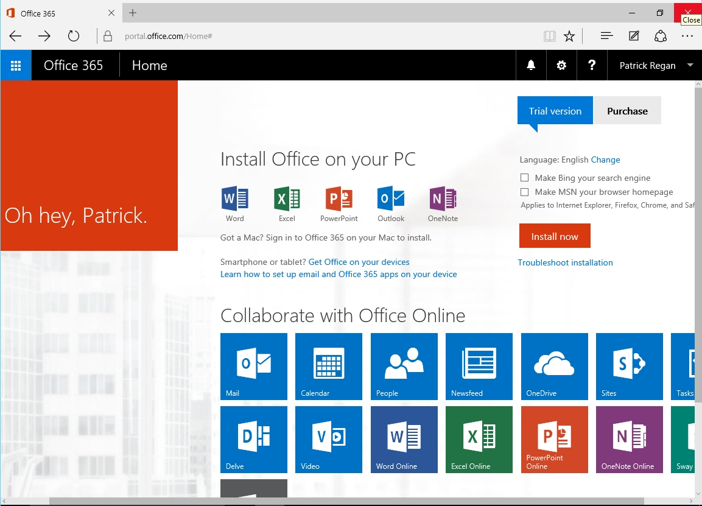

Figure 2-2. Installing Office 2016 from Office 365

